Customer segment

# Algorithm

k means clustering

cluster customers taking independent variable as the income and dependet variable as the spending score

k means mainly used for

* pattern recognition
* segmentation
* partition dataset into distinct groups or clusters

## **How to Apply K-Means Clustering Algorithm?**

1. **Choose the number of clusters k**

The first step in k-means is to pick the number of clusters, k.

* *choose optimum number of clusters we use WCSS(within cluster sum of squares) parameter to find the optimum number of clusters. then plot the elbow graph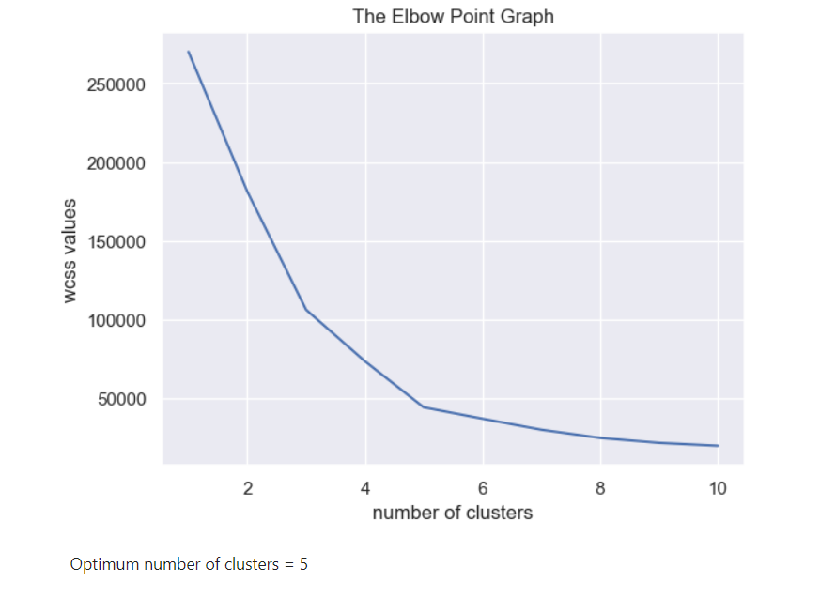*

*find the elbow points and the elbow point that has the lowest wcss value is the optimum number of clusters.*

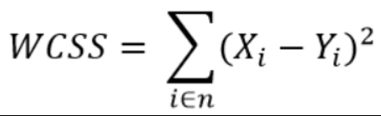

*2)* Train the model

3) visualize all the clusters